**Practical 9**

**Project Management Tool (Taiga)**

1. Write steps to create a project in Taiga

Ans:

* **https://www.taiga.io/** Goto This Site And Click On Login.

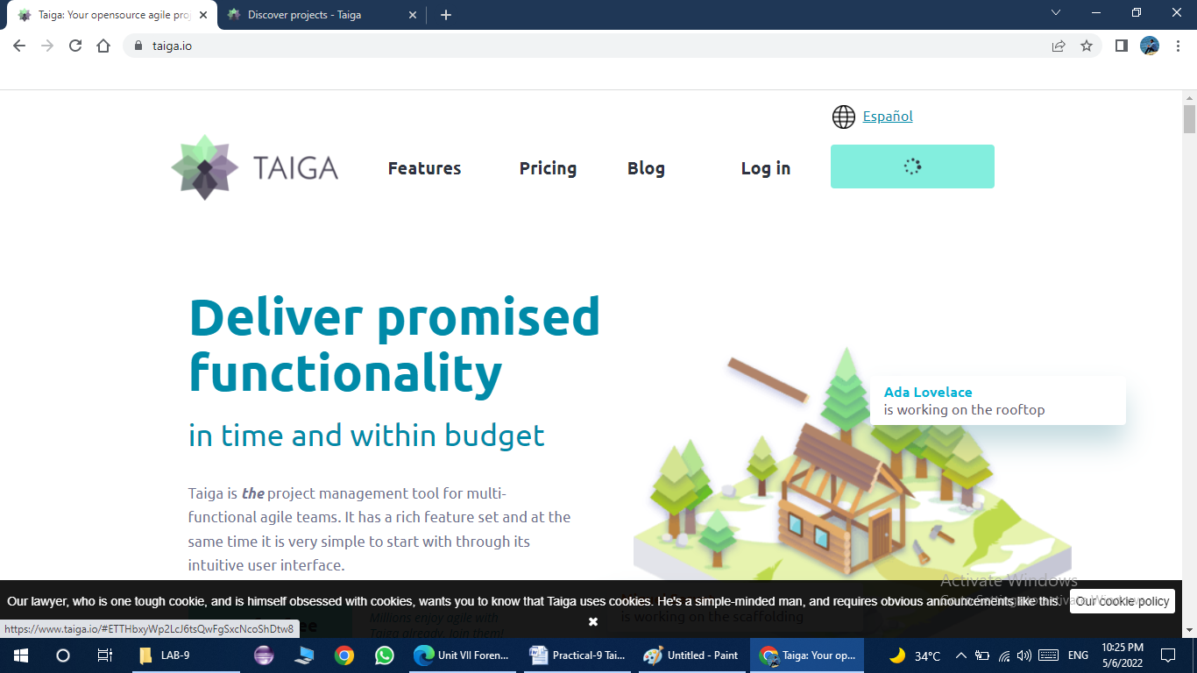

* Login with your username and password

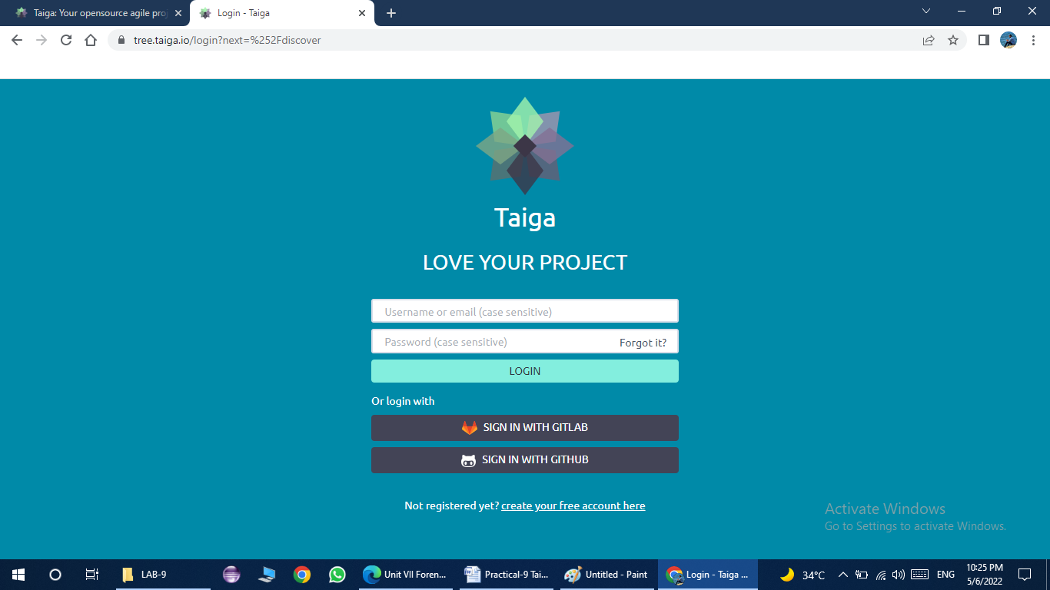

* Click on the Projects button on left top corner and in that click on create project button.

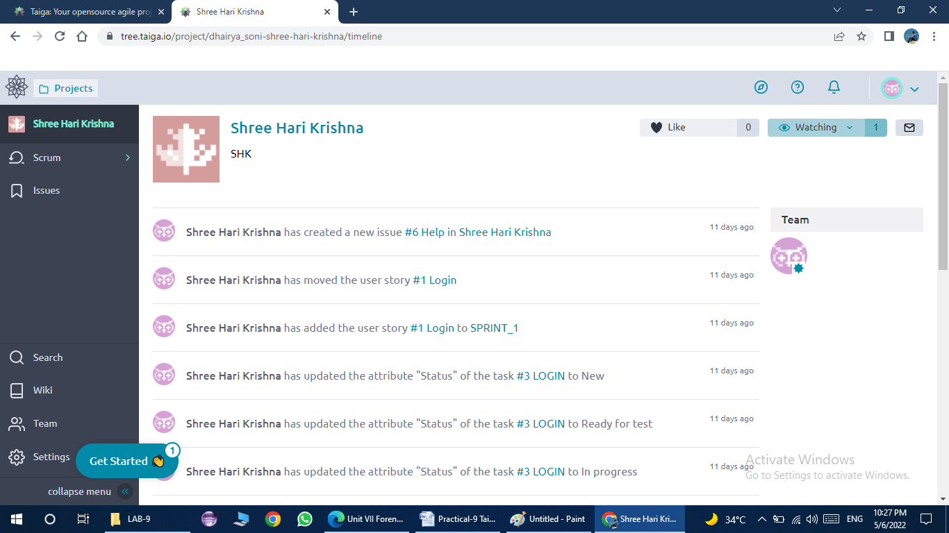

* Next, we need to select Scrum from the given options.

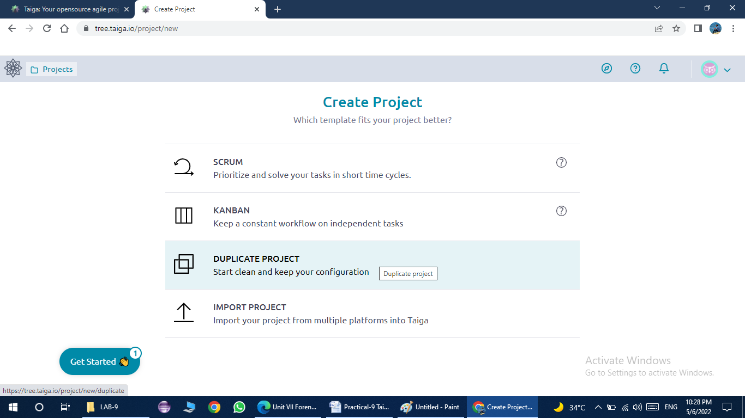

* After that, we need to add our project name and description of project and click on Create Project button.

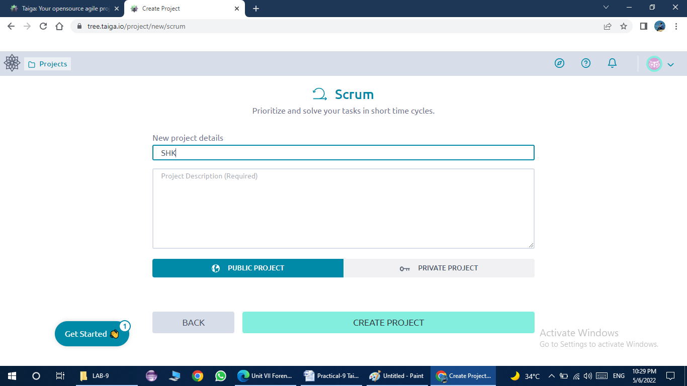

* Now, your project is successfully created.

1. Which functionalities are provided by Taiga for any project? List and explain their purpose.

Ans:

* **Agile**: The system is intended for organizations using agile technologies like Scrum/Kanban and is well suited for those technologies
* **Open source**: The code of Taiga is open so that you can customize it for your needs. You can also watch the discussions about system components, participate in them and thus influence the decisions!
* **Full control of installation** You can install Taiga on-premises in your organization (including behind a firewall or air-gapped) and also in a public or private cloud.
* **The system is built using modern technologies**: It was created in 2015 and is continuously developed. Version 6 was released in January 2021.
* **Intuitive interface**. Taiga is easy to start working with, and you can adapt it to your needs as you work with it.
* **Effective communication within your team**. sharing the progress and information and discussing ideas with members of your team.
* **Helps to plan the work**, prioritize the tasks and work in an orderly manner.
* **Provides visibility** -into the state of the project, both on the level of individual tasks and on the deliverable system level.
* **Supports rapid growth and is suitable for large organizations**: Even on a single server Taiga supports thousands of users. It also supports a high-availability configuration.
* **Ease of migrations**: It is relatively easy to migrate from other systems like Jira, asana, etc.
* **Ease of starting off**: On-premises installation is fast, and if you prefer the SaaS option, you can just sign up and start working.

1. How can you change permissions in Taiga? Write steps to create new points value in Taiga.

Ans:

* In this section of the ADMIN module, you can add or remove the roles that you can assign to project members and you can manage the access rights that each role grants.

When you access this section, you can view a list that shows the existing roles for the current project.



* To manage the access rights that each role grants, click the name of a role – this action displays the manage rights form on the right side of the list that shows the existing roles.

For each role, you can manage access rights for the following elements of the current project:

* Sprints – the actions that you can enable or disable for Sprints are: view, add, modify, delete
* User Stories – the actions that you can enable or disable for User Stories are: view, add, modify, delete
* Tasks – the actions that you can enable or disable for Tasks are: view, add, modify, delete
* Issues – the actions that you can enable or disable for Issues are: view, add, modify, delete
* Wiki – the actions that you can enable or disable for Wiki pages are: view, add, modify, delete and for Wiki links: view, add, delete



**Steps to create a new points value in Taiga:**

* To access this, in the ATTRIBUTES section of the ADMIN module, on the list the shows the available groups of settings, click POINTS.
* On this page, you can view the US POINTS list that shows the values of the points that can be selected when estimating the User Stories of the current project.
* To add a new point for User Story estimations, on the US POINTS list, follow these steps:
* In the top-right of the US POINTS list, click ADD NEW POINT – this action adds a new empty row at the bottom of the US POINTS list.
* On the new row, enter a display name in the empty Name box and a value in the empty box Value box.
* On the right of the Value column, click icon.



1. Write steps to create a sprint and tasks in Taiga. Explain issues in Taiga.

Ans:

* To create Sprint, click on Add sprint and fill sprint details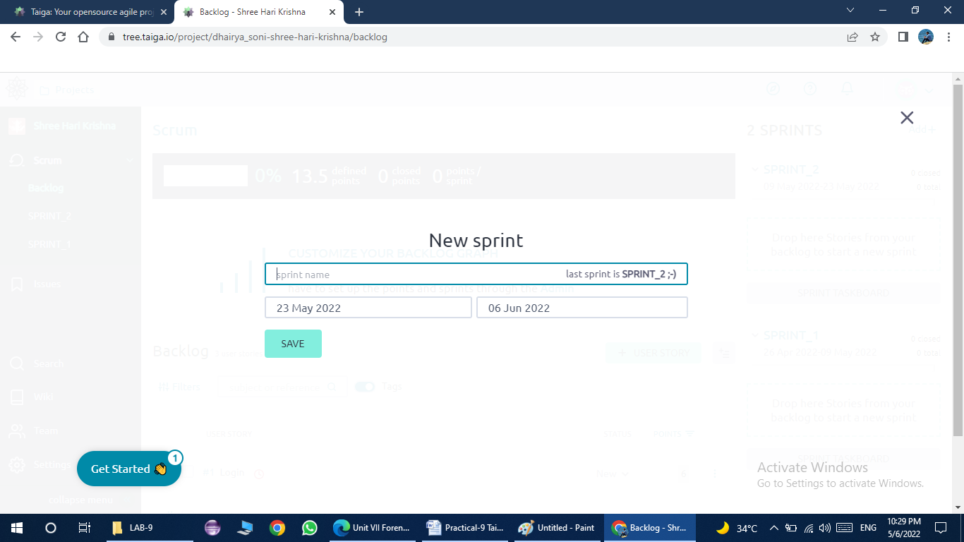
* To add tasks of any User Story you see TASKBOARD page, follow these steps
* On the User Stories list displayed on the TASKBOARD page, on the right side of the subject of the User Story to which you want to add a new Task, click +.
* On the new task form, set up the new task and click on CREATE.



* Issues in Taiga
* To resolve the issues which are being faced by the stakeholder or users before the software.
* So, a software is being developed to resolve those issues.
* Issues can such, developer feel as a issue in developing a software are under issues which is to be discussed with stakeholders meeting.
* To resolve those issues user stories are being created to track the issues of the software.